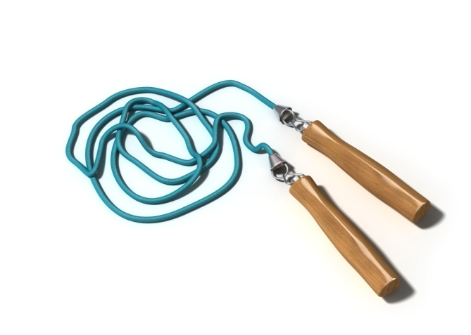
Dawson County Middle School
Physical Education and Health Syllabus
Teacher:
Coach Grigsby
Health Course Description: This course is designed to enhance the student’s knowledge of issues that will allow the student to be a healthier individual. Topics to be covered are nutrition, tobacco, alcohol, drugs and “Choosing the Best Path”: an abstinence focused sex education curriculum.
Physical Education Course Description: The middle school physical education program is designed as a pre-requisite for high school physical education. Our aim is to increase your
child's physical activity with both challenging and/or exciting activities that promote a high level of fitness and a healthy mind-set of team sports. There will be a heavy emphasis on physical fitness and the student's will participate in the Fitness Gram.
Fitness Gram
ONE-MILE WALK/RUN
PACER
RIGHT ANGLE PUSH-UP
CURL-UPS
SIT AND REACH

Course Objectives
*Develop an appreciation in fundamental understanding of the value of
physical education and health and its relationship to a healthy lifestyle.

*Make participation in physical activity a pleasurable experience in
which enjoyment and satisfaction are the same importance of the skills and information.

*Develop the student's awareness of the role that each person plays in
group activities through competition and cooperation with partners.

REQUIRED MATERIALS AND SUPPLIES

Every student will be required to wear tennis shoes for Physical Education.
- Shoes - sturdy laced up tennis shoes.....NO BACKLESS, BOOTS, PLATFORMS, and SANDALS.
- Every student must dress out daily. They will have 5 minutes before and after class to change. Proper footwear is essential for the safety of our student's.
- For safety reasons, jewelry (big earrings, necklaces, bracelets, watches, and rings) are not permitted.

Every student must be prepared for health class.
- Something to write with (pen or pencil)
- Paper
- Notebook
- Portfolios

RULES:
CLASSROOM RULES
- Come in and sit QUIETLY
- Focus on white board (Topic, E.Q., Standard, and Assignments)
- Stay on Task
- To be Acknowledged raise your hand
- RESPECT yourself and others
- NO Food, Drinks or Gum
- Business First, Play Later

LOCKER ROOM RULES
- DO NOT share a locker with any other student.
- NO FOOD, GUM, CANDY, or DRINKS (only water) allowed in the locker room or the gym.
- NO LOTION or PERFUME before class.
- Remove all items from your locker after class.

MEDICAL RULES
- Notes are to be written by parents or guardians only and are valid for two days.
- Doctor's excuses are mandatory for anything over two days.
- If a student is excused from a fitness activity, he/she will be required to make it up.

GENERAL P.E. RULES

- If at any time you hear a whistle, stop what you are doing and listen.
- DO NOT LEAVE THE GYM WITHOUT PERMISSION.
- During class the locker room is off limits unless accompanied by a teacher.

Discipline Procedure:
1st infraction=warning and phone call home
2nd infraction=conference with teacher and phone call home
3rd infraction=conference with teacher, phone call home and isolation
4th infraction=detention and phone call home
5th infraction=parent/teacher conference and written behavior contract
6th infraction=office referral

Proposed MS HPE Reporting and Measurement Topics

Physical Education
Grades  6-7 | Reporting Topic |  | Measurement Topic |  | Associated GPS Standards
Fitness |  | Fitness Level  Personal Fitness Plan |  | Standard 4: Achieves and maintains a health enhancing level of physical fitness.
Physical Activity |  | School-based Physical Activity  Personal Physical Activity |  | Standard 3: Participates regularly in physical activity.  Standard 5: Exhibits responsible personal and social behavior that respects self and others in physical activity.
Skills and Strategies |  | Motor Skills  Strategies and Tactics |  | Standard 1: Demonstrates competency in motor skills and patterns needed to perform a variety of activities.  Standard 2: Demonstrates understanding of movement concepts, principles, strategies, and tactics as they apply to the learning and performance of physical activities.
Social Interactions |  | Preparedness  Sportsmanship and Safety |  | Standard 5: Exhibits responsible personal and social behavior that respects self and others in physical activity.  Standard 6: Values physical activity for health, enjoyment, challenge, self-expression, and/or social interaction.

Proposed MS HPE Reporting and Measurement Topics

Health Education
Grades  6-7 | Reporting Topic |  | Measurement Topic |  | Associated GPS  Standards
Decision Making and Goal Setting |  | Health Product Validity |  | Standard 1: Students will comprehend concepts related to health promotion and disease prevention to enhance health  Standard 2: Students will analyze the influence of family, peers, culture, media, technology, and other factors on health behaviors. Standard 5: Students will demonstrate the ability to use decision-making skills to enhance health.  Standard 6: Students will demonstrate the ability to use goal-setting skills to enhance health.
Health Risks and Enhancements |  | Health Behavior Influences |  | Standard 1: Students will comprehend concepts related to health promotion and disease prevention to enhance health  Standard 3: Students will demonstrate the ability to access valid information, products and services to enhance health.  Standard 7: Students will demonstrate the ability to practice health-enhancing behaviors and avoid or reduce health risks.
Communication |  | Interpersonal Communication  Health Advocacy |  | Standard 4: Students will demonstrate the ability to use interpersonal communication skills to enhance health and avoid or reduce health risks.  Standard 8: Students will demonstrate the ability to advocate for personal, family, and community health

